1. class ParkingSystem {

int big;
int medium;
int small;

public ParkingSystem(int big, int medium, int small) {
this.big = big;
this.medium = medium;
this.small = small;
}

public boolean addCar(int carType) {

if (carType == 1) {

if (big > 0) {
big--;
return true;
}

} else if (carType == 2) {

if (medium > 0) {
medium--;
return true;
}

} else if (carType == 3) {

if (small > 0) {
small--;
return true;
}
}

return false;
}
}
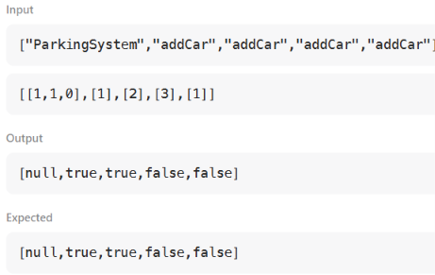
2. import java.util.*;

class Student{}
class Rockstar{}
class Hacker{}

public class InstanceOFTutorial{

static String count(ArrayList mylist){
int a = 0, b = 0, c = 0;
for(int i = 0; i < mylist.size(); i++){
Object element = mylist.get(i);
if(element instanceof Student)
a++;
if(element instanceof Rockstar)
b++;
if(element instanceof Hacker)
c++;
}
String ret = Integer.toString(a) + " " + Integer.toString(b) + " " + Integer.toString(c);
return ret;
}

public static void main(String []args){
ArrayList mylist = new ArrayList();
Scanner sc = new Scanner(System.in);
int t = sc.nextInt();
for(int i = 0; i < t; i++){
String s = sc.next();
if(s.equals("Student")) mylist.add(new Student());
if(s.equals("Rockstar")) mylist.add(new Rockstar());
if(s.equals("Hacker")) mylist.add(new Hacker());
}
System.out.println(count(mylist));
}
}

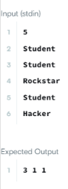
3. import java.util.*;

class UndergroundSystem {

// Stores customer ID -> [stationName, checkInTime]
private Map<Integer, Pair> checkIns;

// Stores route -> [total travel time, number of trips]
private Map<String, double[]> routes;

public UndergroundSystem() {
checkIns = new HashMap<>();
routes = new HashMap<>();
}

public void checkIn(int id, String stationName, int t) {
checkIns.put(id, new Pair(stationName, t));
}

public void checkOut(int id, String stationName, int t) {
Pair start = checkIns.get(id);

String route = start.station + "#" + stationName;

int travelTime = t - start.time;

if (!routes.containsKey(route)) {
routes.put(route, new double[]{0, 0});
}

routes.get(route)[0] += travelTime; // total time
routes.get(route)[1] += 1; // number of trips

checkIns.remove(id);
}

public double getAverageTime(String startStation, String endStation) {
String route = startStation + "#" + endStation;

double[] data = routes.get(route);

return data[0] / data[1];
}

// Helper class
static class Pair {
String station;
int time;

Pair(String station, int time) {
this.station = station;
this.time = time;
}
}
}
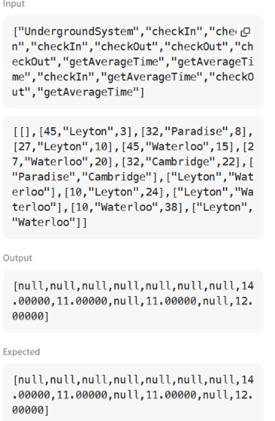
4. import java.util.*;

class BrowserHistory {

private ArrayList<String> history;
private int current;

public BrowserHistory(String homepage) {
history = new ArrayList<>();
history.add(homepage);
current = 0;
}

public void visit(String url) {

// Remove all forward history
while (history.size() > current + 1) {
history.remove(history.size() - 1);
}

// Add new URL
history.add(url);

// Move to the new page
current++;
}

public String back(int steps) {

current = Math.max(0, current - steps);

return history.get(current);
}

public String forward(int steps) {

current = Math.min(history.size() - 1, current + steps);

return history.get(current);
}
}
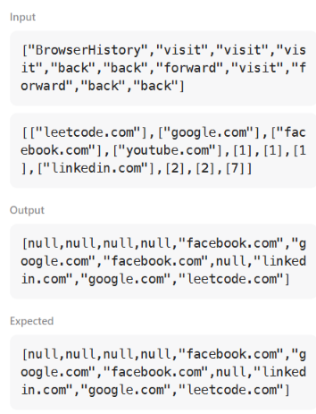
5. class MyHashSet {

private boolean[] set;

public MyHashSet() {
set = new boolean[1000001];
}

public void add(int key) {
set[key] = true;
}

public void remove(int key) {
set[key] = false;
}

public boolean contains(int key) {
return set[key];
}
}
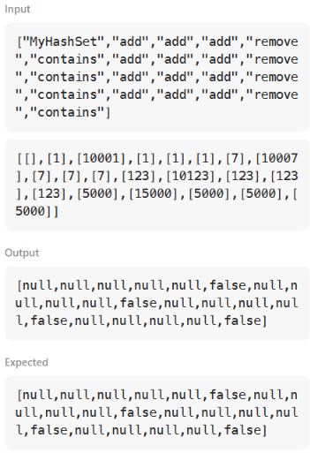

6.import java.io.*;
import java.util.*;
import java.util.stream.*;
import static java.util.stream.Collectors.joining;
import static java.util.stream.Collectors.toList;

class Result {

/*
* Complete the 'gradingStudents' function below.
*
* The function is expected to return an INTEGER_ARRAY.
* The function accepts INTEGER_ARRAY grades as parameter.
*/

public static List<Integer> gradingStudents(List<Integer> grades) {

List<Integer> result = new ArrayList<>();

for (int grade : grades) {

// If grade is less than 38, do not round
if (grade < 38) {
result.add(grade);
} else {

// Find the next multiple of 5
int nextMultiple = ((grade / 5) + 1) * 5;

// Round if difference is less than 3
if (nextMultiple - grade < 3) {
result.add(nextMultiple);
} else {
result.add(grade);
}
}
}

return result;
}
}

public class Solution {

public static void main(String[] args) throws IOException {

BufferedReader bufferedReader =
new BufferedReader(new InputStreamReader(System.in));

BufferedWriter bufferedWriter =
new BufferedWriter(new FileWriter(System.getenv("OUTPUT_PATH")));

int gradesCount =
Integer.parseInt(bufferedReader.readLine().trim());

List<Integer> grades = IntStream.range(0, gradesCount)
.mapToObj(i -> {
try {
return bufferedReader.readLine().trim();
} catch (IOException ex) {
throw new RuntimeException(ex);
}
})
.map(Integer::parseInt)
.collect(toList());

List<Integer> result = Result.gradingStudents(grades);

bufferedWriter.write(
result.stream()
.map(Object::toString)
.collect(joining("\n"))
);

bufferedWriter.newLine();

bufferedReader.close();
bufferedWriter.close();
}
}
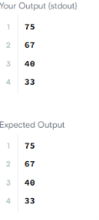
7. import java.io.*;
import java.util.*;
import java.text.*;
import java.math.*;
import java.util.regex.*;

class Animal{
void walk()
{
System.out.println("I am walking");
}
}
class Bird extends Animal {
void fly() {
System.out.println("I am flying");
}

void sing() {
System.out.println("I am singing");
}
}
public class Solution{

public static void main(String args[]){

Bird bird = new Bird();
bird.walk();
bird.fly();
bird.sing();

}
}
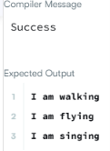
8.import java.io.*;
import java.util.*;
import java.text.*;
import java.math.*;
import java.util.regex.*;
class Arithmetic {
public int add(int a, int b) {
return a + b;
}
}

class Adder extends Arithmetic {
}

public class Solution{
public static void main(String []args){
// Create a new Adder object
Adder a = new Adder();

// Print the name of the superclass on a new line
System.out.println("My superclass is: " + a.getClass().getSuperclass().getName());

// Print the result of 3 calls to Adder's `add(int,int)` method as 3 space-separated integers:
System.out.print(a.add(10,32) + " " + a.add(10,3) + " " + a.add(10,10) + "\n");
}
}
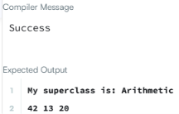
9
. import java.io.*;
import java.util.*;

class Printer {

public <T> void printArray(T[] array) {
for (T element : array) {
System.out.println(element);
}
}
}

public class Solution {

public static void main(String[] args) {

Integer[] intArray = {1, 2, 3};
String[] stringArray = {"Hello", "World"};

Printer printer = new Printer();

printer.printArray(intArray);
printer.printArray(stringArray);
}
}
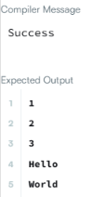
10. import java.util.*;

class ThroneInheritance {

private String king;
private Map<String, List<String>> children;
private Set<String> dead;

public ThroneInheritance(String kingName) {
king = kingName;
children = new HashMap<>();
dead = new HashSet<>();

children.put(kingName, new ArrayList<>());
}

public void birth(String parentName, String childName) {
children.putIfAbsent(childName, new ArrayList<>());
children.get(parentName).add(childName);
}

public void death(String name) {
dead.add(name);
}

public List<String> getInheritanceOrder() {
List<String> order = new ArrayList<>();

dfs(king, order);

return order;
}

private void dfs(String person, List<String> order) {

// Add person only if they are alive
if (!dead.contains(person)) {
order.add(person);
}

// Visit children from oldest to youngest
for (String child : children.getOrDefault(person, new ArrayList<>())) {
dfs(child, order);
}
}
}
